DOGUKAN KOC  
OTOPARK YONETIM PROJESI

Ad: DOGUKAN KOC

Sınıf: 10-G Bilisim

Ders: Robotik Kodlama (Aurdinio)

Proje Dili: Aurdinio (C++)

Proje GitHub Reposu: https://github.com/L9CS/Arduino-Otopark

Diğer GitHub’da bulunan projelerimiz: https://github.com/L9CS

PROJE ANLATIMI

Proje ile ilgili gerekli dokümanlar ve resimler ve kod blokları aşağıdadır.

1. PROGRAMA GIRIŞ

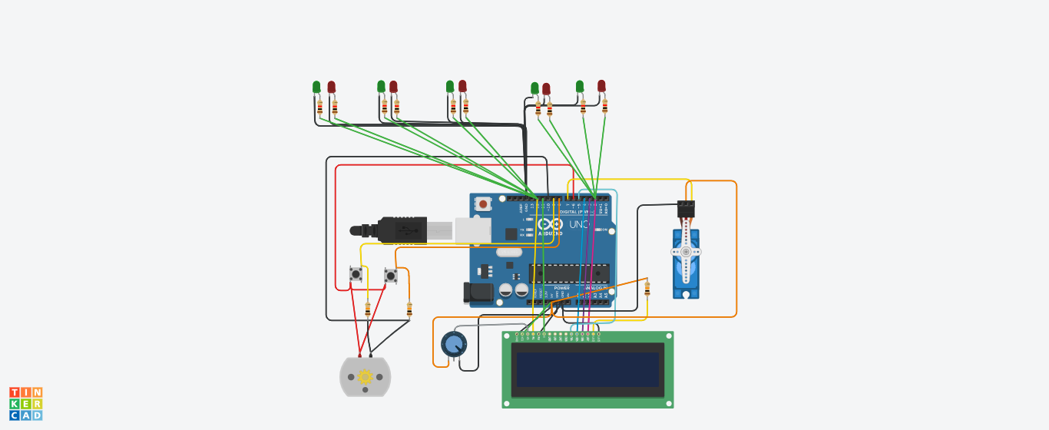

Program Kodları:

|  |
| --- |
| #include <Servo.h>  #include<LiquidCrystal.h>  LiquidCrystal **lcd**(**12**,**11**,**5**,**4**,**3**,**2**);  Servo myservo;  #define ServoM 7  #define Exit 9  #define In 8  #define Pwr 6  #define Gnd 10  #define BarLow 90  #define BarUp 177  #define CAPACITY 7  **void** **setup**(){  myservo.attach(ServoM);  lcd.begin(**16**,**2**);  lcd.print("Kalan bos yer:");  pinMode(Gnd, OUTPUT);  pinMode(Pwr, OUTPUT);  pinMode(Exit, INPUT);  pinMode(In, INPUT);  digitalWrite(Gnd, LOW);  digitalWrite(Pwr, HIGH);  myservo.write(BarLow);  // delay(1000);  }  **int** Available= **7**;  //================================================================  **void** **loop**(){  **if** (Available == **1**){  lcd.clear();  lcd.setCursor(**1**,**0**);  lcd.print("Kalan boş yer:");  lcd.setCursor(**0**,**1**);  lcd.print(Available);  lcd.print(" araba");  }**else**{  **if** (Available >= **1**){  lcd.clear();  lcd.setCursor(**1**,**0**);  lcd.print("Kalan bos yer:");  lcd.setCursor(**0**,**1**);  lcd.print(Available);  lcd.print(" araba");  }**else**{  lcd.clear();  lcd.setCursor(**1**,**0**);  lcd.print("Uzgunuz!");  lcd.setCursor(**0**,**1**);  lcd.print("Hic yer kalmadı!");  }  }  **if**(digitalRead(In)==**1**)  {  **if**(Available != **0**){  Available--;  myservo.write(BarUp);  delay(**3000**);  myservo.write(BarLow);  }  }  **if**(digitalRead(Exit)==**1**)  {  **if**(Available != CAPACITY){  Available++;  myservo.write(BarUp);  delay(**3000**);  myservo.write(BarLow);  }  }  delay(**20**);  } |